ANIL NEERUKONDA INSTITUTE OF TECHNOLOGY & SCIENCES (AUTONOMOUS)
(Permanent Affiliation by Andhra University & Approved by AICTE Accredited by NBA (ECE, EEE, CSE, IT, Mech, Civil & Chemical) & NAAC with A+ Grade) Sangivalasa-531162, Bheemunipatnam Mandal, Visakhapatnam District
A PROJECT WORK REPORT ON..
AI BASED MEMORY ALLOCATION SIMULATOR
This project is submitted by
B.Revanth | A25126510270
G.Bhavya Bhashini | A25126510280
K.Satwik | A25126510290
M.Vivek Satya Bhushan | A25126510300
Under the Guidance of Dr B.MAHESH
Department of Computer Science and Engineering
in partial fulfillment of the requirements for the award of the offered by

B.TECH IN
COMPUTER SCIENCE AND ENGINEERING 2026-2029
ANIL NEERUKONDA INSTITUTE OF TECHNOLOGY & SCIENCES (AUTONOMOUS)
(Permanent Affiliation by Andhra University & Approved by AICTE Accredited by NBA (ECE, EEE, CSE, IT, Mech, Civil & Chemical) & NAAC with A+ Grade) Sangivalasa-531162, Bheemunipatnam Mandal, Visakhapatnam District
CERTIFICATE
This is to certify that this project work entitled “AI BASED MEMORY ALLOCATION SIMULATOR” is the bona fide record work done by
B.Revanth | A25126510270
G.Bhavya Bhashini | A25126510280
K.Satwik | A25126510290
M.Vivek Satya Bhushan | A25126510300
of the Second Year, along with their batchmates, submitted in partial fulfillment of the requirement for the award of Bachelor of Technology (B.Tech) in Computer Science and Engineering to the Anil Neerukonda Institute of Technology and Sciences.
The results embodied in this project report have not been submitted to any other Board, University, or Institute for the award of any diploma or degree.
HEAD OF THE DEPARTMENT LECTURER IN CHARGE
ACKNOWLEDGEMENT
I would like to express my sincere gratitude to all those who have contributed to the successful completion of this project.
First and foremost, I extend my heartfelt thanks to my project guide, DR B.MAHESH, for their valuable guidance, continuous support, and encouragement throughout the development of this project. Their insightful feedback and expert advice were instrumental in shaping this work.
I am also grateful to the faculty members of Computer Science and Engineering, ANIL NEERUKONDA INSTITUTE OF TECHNOLOGY AND SCIENCES, for providing the necessary resources and a conducive environment for research and learning.
A special thanks to my friends and classmates for their cooperation, constructive suggestions, and moral support during every stage of this project.
Finally, I would like to thank my family for their unwavering love, patience, and constant motivation that kept me focused and determined.
This project, titled “AI BASED MEMORY ALLOCATION SIMULATOR”, has been a great learning experience, helping me enhance my technical skills and practical understanding of the subject.
ABSTRACT
Memory allocation is one of the most important functions performed by an operating system. Efficient allocation of memory improves system performance and resource utilization. Traditional memory allocation algorithms such as First Fit, Best Fit, and Worst Fit have different behaviors depending on workload characteristics.
The AI Based Memory Allocation Simulator is developed to simulate and compare these memory allocation techniques. The system accepts memory block sizes and process sizes as input and performs allocation using First Fit, Best Fit, and Worst Fit algorithms. Memory blocks are represented using a Doubly Linked List to demonstrate dynamic memory management using Data Structures.
In addition, a Machine Learning model is integrated into the system to analyze workload characteristics and recommend the most suitable allocation strategy. The AI module predicts the best algorithm based on factors such as total memory, process sizes, memory pressure, and block distribution.
The project provides a practical understanding of operating system memory management, algorithm comparison, data structures, and the application of Artificial Intelligence in optimization problems.
PREFACE
Table of contents
Sl.No. | Chapter Title | Sub-Contents | Page No.
1 | Introduction | - Overview of the Project  - Purpose and Scope  - Existing System and Proposed System | 1
2 | Problem Definition | - Problem Statement  - Objectives of the System | 2
3 | System Design | - System Architecture  - Flowcharts (Booking, Cancellation, etc.)  - Algorithms Used | 3-11
4 | Implementation Details | - Program Structure  - Language and Environment Used  - Key Functional Modules  - Code Snippets and Screenshots  - File Handling Explanation | 12-17
5 | Results and Discussion | - Output Screens  - Test Case Table (Input, Expected Output, Actual Output) | 18-22
6 | Conclusion | - Summary of Achievements  - Limitations of the System  - Future Enhancements | 23
7 | References | - Books Referred  - Research Papers  - Websites and Online Resources | 24
8 | Appendix | - Source Code Listings  - Source Code | 25-37

1. INTRODUCTION
Overview:

Memory management is an important component of operating systems. The operating system must allocate available memory efficiently to different processes. Improper allocation may lead to memory wastage and reduced system performance.

This project simulates memory allocation using First Fit, Best Fit, and Worst Fit algorithms and uses Artificial Intelligence to recommend the most suitable allocation strategy.

Purpose:
- Study memory allocation algorithms.
- Compare their performance.
- Analyze memory utilization.
- Apply AI techniques for intelligent decision making.

Scope:
- Memory allocation simulation.
- Fragmentation analysis.
- Algorithm comparison.
- AI-based recommendation.
- Educational and research purposes.

Existing System:
Traditional memory allocation methods use fixed algorithms without analyzing workload characteristics. The same algorithm may not always provide optimal performance.

Proposed System:
The proposed system compares multiple allocation algorithms and uses Machine Learning to recommend the most suitable strategy for a given workload.

2. PROBLEM DEFINITION
Problem Statement:
Operating systems must allocate memory efficiently among processes. Different memory allocation algorithms produce different levels of memory utilization and fragmentation. Selecting the best algorithm manually is difficult because performance depends on workload characteristics.

Objectives:
- Simulate memory allocation algorithms.
- Implement First Fit, Best Fit, and Worst Fit.
- Represent memory blocks using Doubly Linked Lists.
- Compare allocation efficiency.
- Develop an AI model for strategy recommendation.
- Reduce memory wastage through intelligent selection.

3. SYSTEM DESIGN / METHODOLOGY
The AI Based Memory Allocation Simulator is designed to simulate memory allocation techniques and recommend the most suitable allocation strategy using Artificial Intelligence. The system accepts memory block sizes and process sizes as input, performs memory allocation using First Fit, Best Fit, and Worst Fit algorithms, analyzes the results, and finally predicts the best strategy using a Machine Learning model.

System Methodology
Step 1: User enters memory block sizes and process sizes.
Step 2: Memory blocks are represented using a Doubly Linked List.
Step 3: The allocation algorithms (First Fit, Best Fit, and Worst Fit) are executed independently.
Step 4: Each algorithm allocates processes to suitable memory blocks.
Step 5: The system calculates:
- Number of allocated processes
- Number of unallocated processes
- Remaining free memory
Memory utilization
Step 6: Workload features are extracted and sent to the AI Prediction Module.
Step 7: The trained Machine Learning model analyzes the workload characteristics.
Step 8: The AI module recommends the most suitable allocation strategy.
Step 9: Final results and recommendations are displayed to the user.

Data Structures Used

1. Doubly Linked List
A Doubly Linked List is used to represent memory blocks.
Structure:
struct Block
{
int id;
int size;
struct Block *prev;
struct Block *next;
};
Each node stores:
- Block ID
- Block Size
- Previous Node Address
- Next Node Address
Purpose:
- Dynamic representation of memory blocks
- Efficient traversal in both directions
- Easy modification of memory block sizes after allocation

2. Arrays
Arrays are used to store:
- Memory Block Sizes
- Process Sizes
Example:
int memory[MAX];
int process[MAX];

Purpose:
- Fast access to input data
- Simple storage of memory and process information

3. Structures
Structures are used to group related information of memory blocks into a single unit.

Purpose:
Better organization of data
Improved readability and maintainability

Algorithms Used

1. First Fit Algorithm
Description:
The First Fit algorithm allocates a process to the first memory block that is large enough to accommodate it.

Working:
- Start from the first memory block.
- Check whether the block size is greater than or equal to the process size.
- If suitable, allocate the process.
- Update the remaining block size.
- Move to the next process.
Advantages:
- Simple implementation
- Fast execution
Disadvantages:
- May increase fragmentation
Time Complexity: O(n × m)
where: n = Number of Processes m = Number of Memory Blocks

2. Best Fit Algorithm
Description:
The Best Fit algorithm allocates a process to the smallest available memory block that can accommodate it.
Working:
- Scan all memory blocks.
- Find the smallest suitable block.
- Allocate the process.
- Update remaining memory.
- Repeat for all processes.
Advantages:
- Better memory utilization
- Reduces internal fragmentation
Disadvantages:
- Requires searching all blocks
Time Complexity: O(n × m)
where: n = Number of Processes m = Number of Memory Blocks

3. Worst Fit Algorithm
Description:
The Worst Fit algorithm allocates a process to the largest available memory block.
Working:
- Scan all memory blocks.
- Find the largest suitable block.
- Allocate the process.
- Update remaining memory.
- Repeat for all processes.
Advantages:
- Preserves medium-sized free blocks
Disadvantages:
- May waste memory space
Time Complexity: O(n × m)
where: n = Number of Processes m = Number of Memory Blocks

4. AI Prediction Algorithm
Description:
The AI module predicts the most suitable allocation strategy using a trained Machine Learning model.
Input Features:
- Number of Memory Blocks
- Total Memory
- Number of Processes
- Total Requested Memory
- Mean Process Size
- Mean Block Size
- Maximum Block Size
- Maximum Process Size
- Memory Pressure
- Standard Deviation of Block Sizes
- Standard Deviation of Process Sizes
Working:
- Extract workload features.
- Load the trained model.
- Generate prediction.
- Calculate confidence scores.
- Recommend the best allocation strategy.
Output:
- Recommended Strategy
- Confidence Percentage
- Comparison of Allocation Results

The AI module helps users select the most efficient memory allocation technique for a given workload.

Flowcharts
Flowchart of Main Program
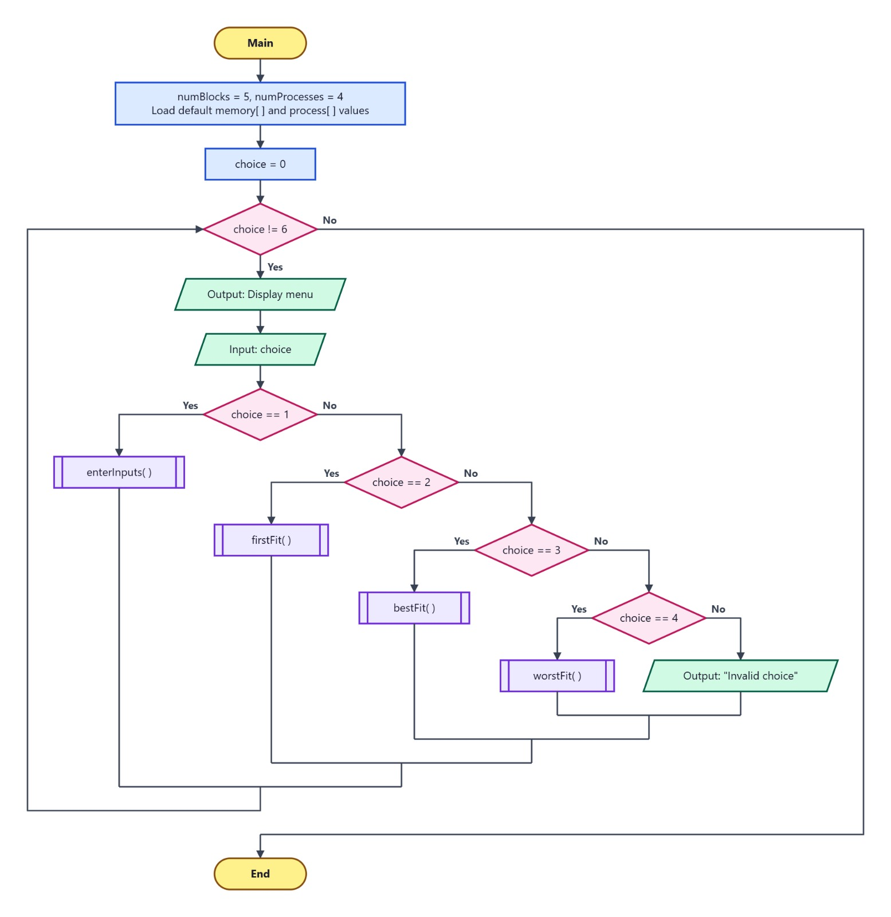
Flowchart of First Fit
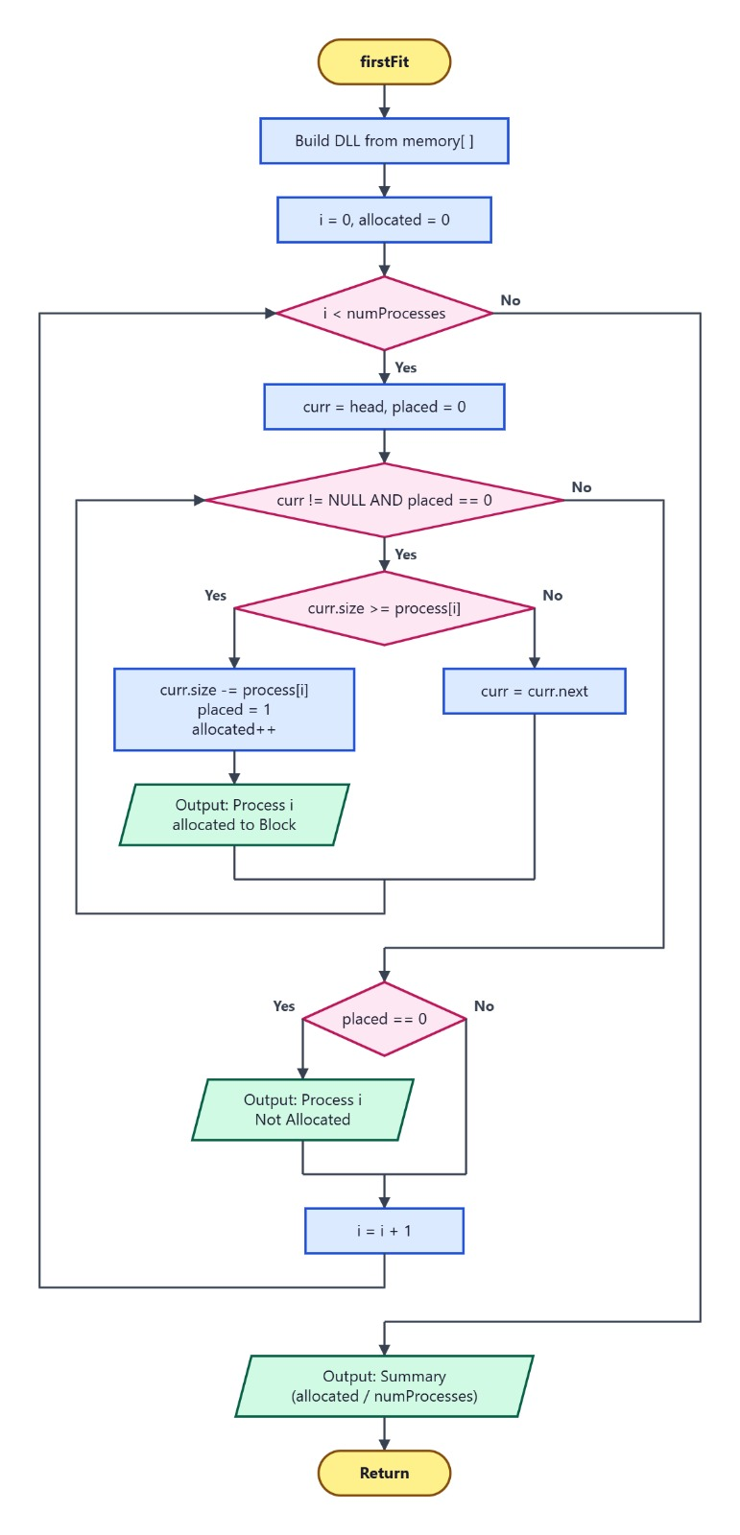
Flowchart of Best Fit
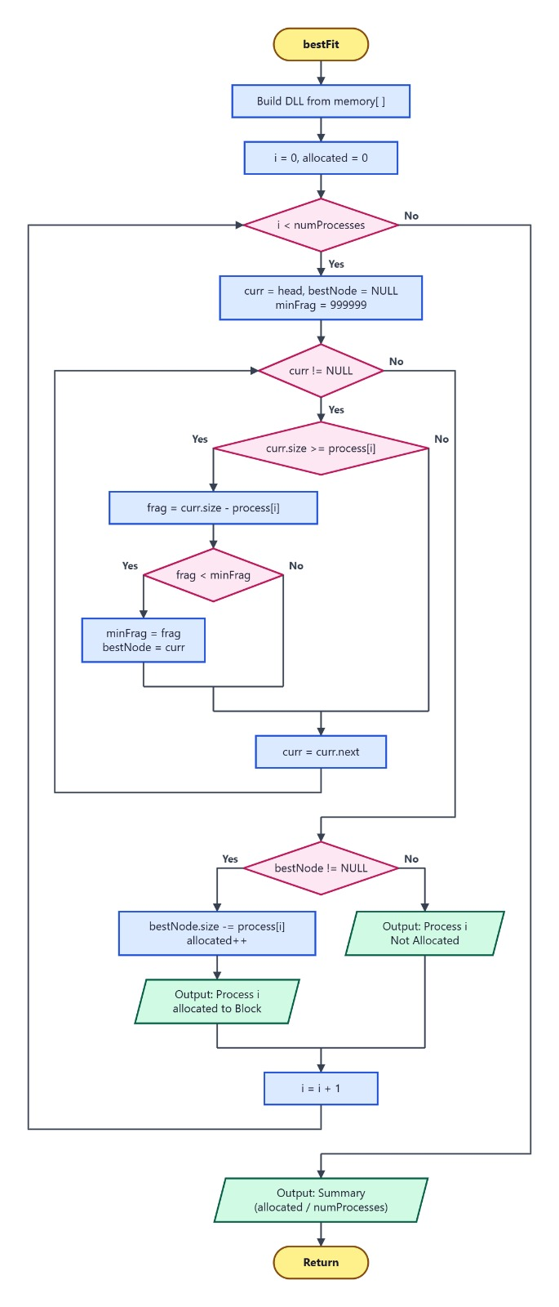
Flowchart of Worst Fit
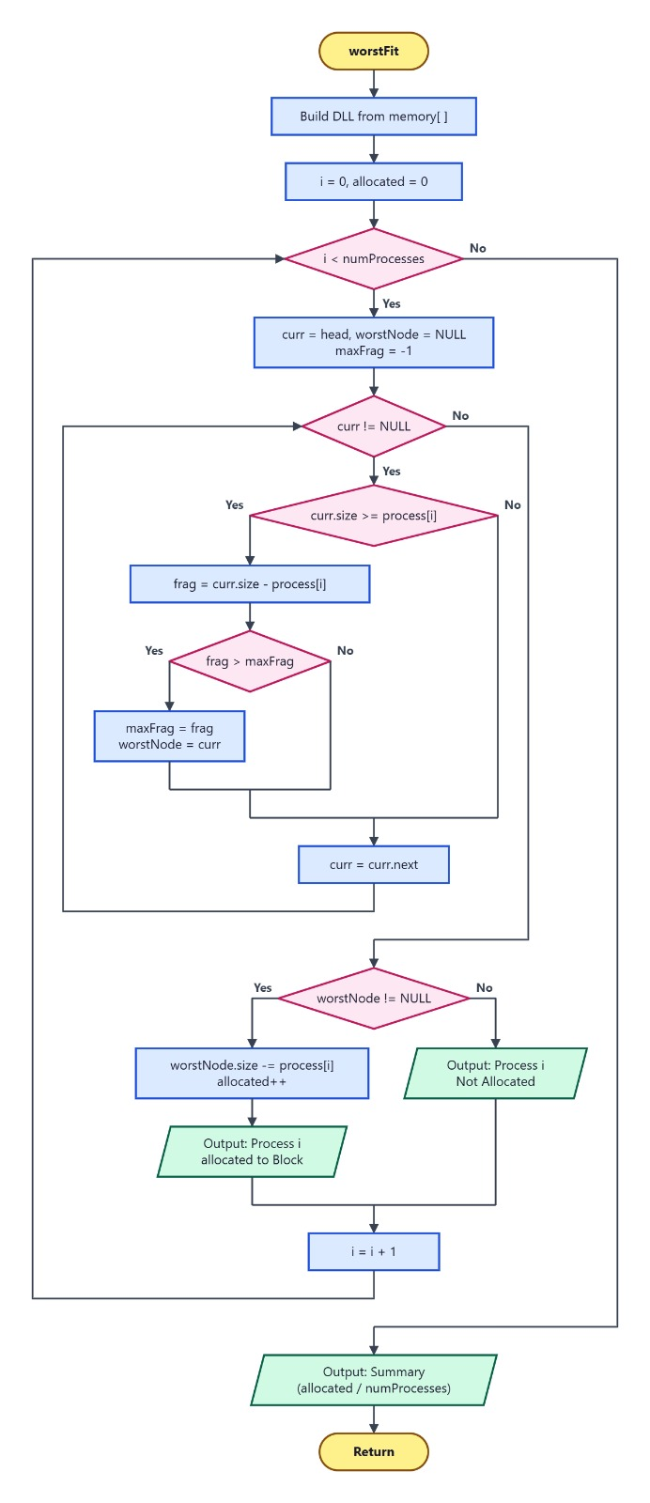

4. IMPLEMENTATION

4.1 Program Structure
The AI Based Memory Allocation Simulator is developed using a modular approach. The project consists of a C-based memory allocation module and a Python-based AI prediction module. The C module performs memory allocation using First Fit, Best Fit, and Worst Fit algorithms, while the Python module analyzes workload characteristics and recommends the most suitable allocation strategy.
The major modules are:
1. Memory Block Management Module
This module creates and manages memory blocks using a Doubly Linked List.
Functions:
- createNode()
- createList()
- freeList()

Purpose:
- Create memory block nodes
- Connect nodes using previous and next pointers
- Manage memory dynamically
2. Input Module
This module accepts memory block sizes and process sizes from the user.
Functions:
- inputMemory()
- inputProcess()

Purpose:
- Read memory block information
- Read process information
- Store input values in arrays

3. Memory Allocation Module
This module performs memory allocation using three allocation techniques.
Functions:
- firstFit()
- bestFit()
- worstFit()

Purpose:
- Allocate processes to suitable memory blocks
- Update remaining memory
- Calculate allocation statistics
4. Result Analysis Module
This module evaluates algorithm performance.
Measures:
- Allocated Processes
- Unallocated Processes
- Remaining Memory
- Memory Utilization

Purpose:
- Compare algorithm efficiency
- Generate allocation reports

5. AI Recommendation Module
This module predicts the most suitable allocation strategy using Machine Learning.
Functions:
- simulate()
- predict_best_strategy()

Purpose:
- Extract workload features
- Load trained model
- Predict optimal strategy
- Display confidence scores

4.2 Language and Development Environment
The AI Based Memory Allocation Simulator is developed using both C and Python programming languages. C is used to implement memory allocation algorithms and data structures, while Python is used for Artificial Intelligence based strategy prediction.

C Language
C is used for implementing the core memory allocation simulator.
Applications:
- Memory Block Management
- Doubly Linked List Implementation
- First Fit Algorithm
- Best Fit Algorithm
- Worst Fit Algorithm
- Result Display

Libraries Used:
#include <stdio.h>
#include <stdlib.h>

Python Language
Python is used for developing the AI recommendation module.
Applications:
- Workload Analysis
- Feature Extraction
- Strategy Prediction
- Model Loading
- Confidence Calculation

Libraries Used:
import os
import pickle
import numpy as np
import pandas as pd

Development Environment
Component | Technology Used
Programming Language | C
AI Module Language | Python
Data Structure | Doubly Linked List
IDE | VS Code / CodeBlocks
Operating System | Windows
Dataset Format | CSV
Model Storage | Pickle (.pkl)

4.3 Data Representation
Memory block sizes and process sizes are stored using arrays. Memory blocks are represented using a Doubly Linked List.
int memory[MAX];
int process[MAX];

struct Block
{
int id;
int size;
struct Block *prev;
struct Block *next;
};
This representation helps in efficient memory management and allocation.

4.4 Module Implementation
The project is divided into the following modules:

Memory Block Module
- Creates memory block nodes.
- Builds the Doubly Linked List.

Input Module
- Accepts memory block sizes.
- Accepts process sizes.
- Allocation Module
- Executes First Fit.
- Executes Best Fit.
- Executes Worst Fit.

Result Module
- Displays allocation results.
- Shows remaining free memory.

AI Recommendation Module
- Analyzes workload features.
- Predicts the best allocation strategy.

4.5 AI Dataset Generation
Multiple memory allocation scenarios are generated using different memory blocks and process sizes. The results of First Fit, Best Fit, and Worst Fit algorithms are recorded and stored in a CSV dataset. This dataset is used for training the Machine Learning model.

4.6 Machine Learning Model Implementation
The AI module extracts workload features such as total memory, total requested memory, number of blocks, and process sizes. The trained model analyzes these features and predicts the most suitable memory allocation strategy. The prediction result is displayed along with confidence values.

4.7 Output Generation
The system displays:
- Memory block information
- Process information
- Allocation results
- Remaining free memory
- Recommended allocation strategy
- Confidence percentages
The generated output helps users compare different memory allocation techniques and identify the most suitable strategy for a given workload.

5. OUTPUT SCREENS
5.1 Program Execution
The program starts by displaying the main menu of the AI Based Memory Allocation Simulator. Default memory blocks and process sizes are loaded automatically. The user can choose to enter new memory blocks and processes, execute First Fit, Best Fit, or Worst Fit algorithms, display memory block information, or exit the program.
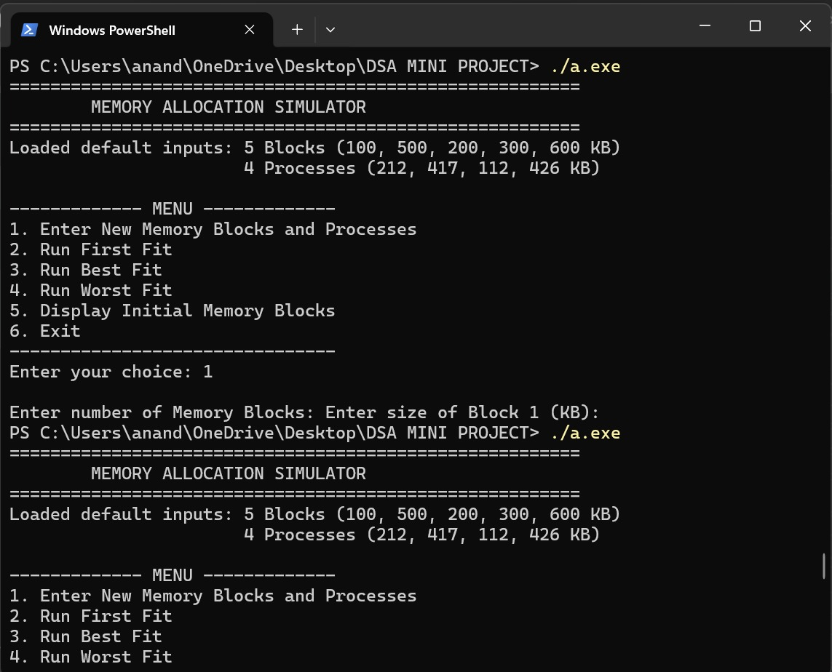
5.2 First Fit Execution
The First Fit algorithm allocates each process to the first available memory block that is large enough. After allocation, the remaining memory of the selected block is updated and displayed.
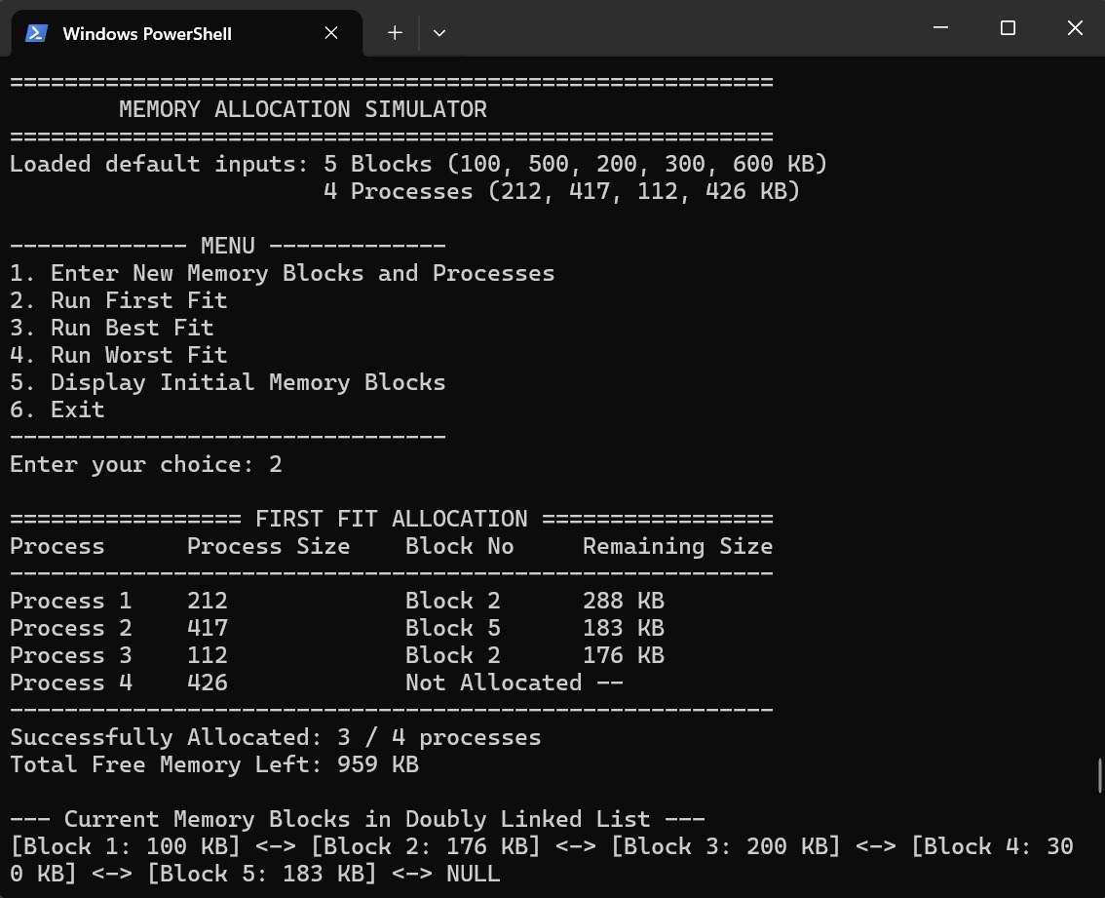
5.3 Best Fit Execution
The Best Fit algorithm searches all available memory blocks and allocates the process to the smallest suitable block. This improves memory utilization and reduces fragmentation.
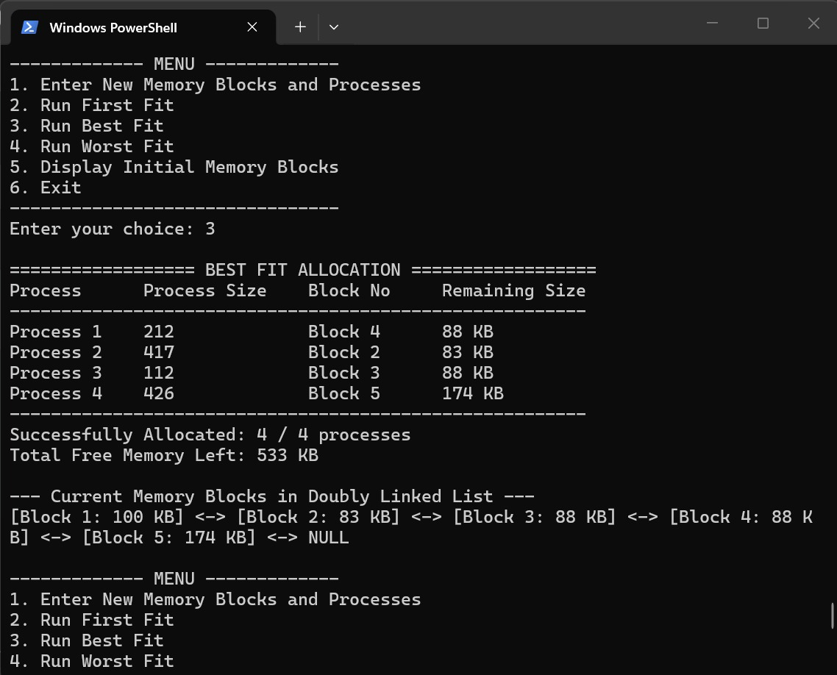
5.4 Worst Fit Execution
The Worst Fit algorithm allocates the process to the largest available memory block. The remaining memory after allocation is displayed for performance comparison.
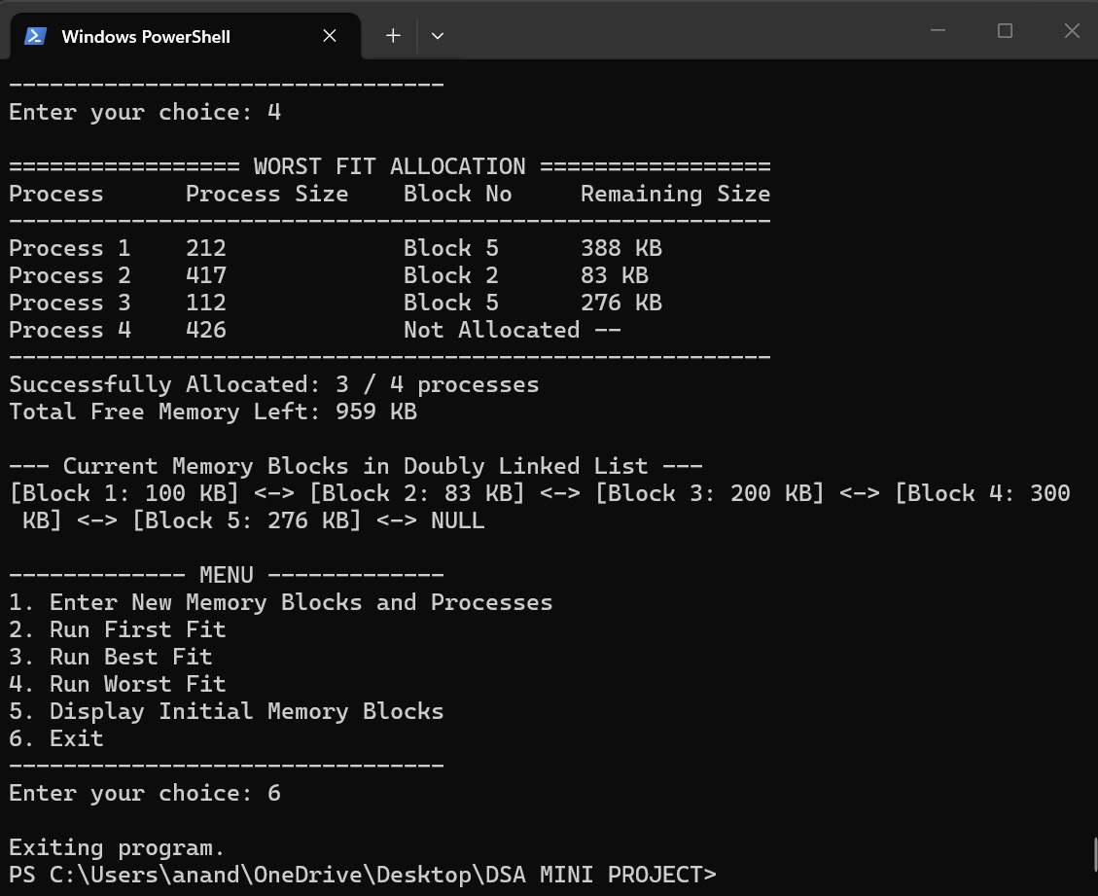
5.5 AI Recommendation Output
The AI module analyzes memory block sizes, process sizes, memory pressure, and workload characteristics. Based on these features, the trained Machine Learning model recommends the most suitable memory allocation strategy and displays confidence values.
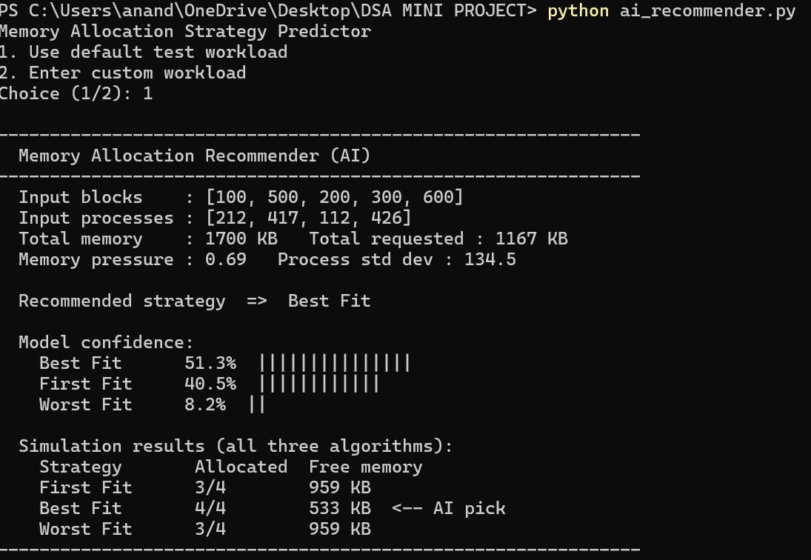
5.6 Overall Result Analysis
The simulator successfully implemented First Fit, Best Fit, and Worst Fit memory allocation techniques using a Doubly Linked List. The results indicate that allocation performance varies depending on memory and process characteristics.
The AI module provided an intelligent recommendation by analyzing workload features and comparing algorithm performance. This demonstrates the usefulness of Artificial Intelligence in supporting memory management decisions.

6. CONCLUSION AND FUTURE SCOPE
6.1 Conclusion

The AI Based Memory Allocation Simulator was successfully designed and implemented using C and Python programming languages. The project demonstrated the working of three memory allocation techniques namely First Fit, Best Fit, and Worst Fit. Memory blocks were represented using a Doubly Linked List, which provided an efficient way to manage and update memory during allocation.

The simulator compares the performance of different allocation strategies based on memory utilization and remaining free memory. In addition, an AI-based recommendation module was developed to analyze workload characteristics and predict the most suitable allocation strategy.

The results show that different algorithms perform differently for different workloads and that Artificial Intelligence can assist in selecting an appropriate strategy.

This project helped in understanding concepts related to Data Structures, Memory Management, Operating Systems, and Machine Learning while providing a practical solution for memory allocation analysis.

6.2 Future Scope
The project can be enhanced further in the following ways:
- Implement additional memory allocation algorithms such as Next Fit and Buddy System.
- Develop a Graphical User Interface (GUI) for better visualization.
- Improve the AI model using larger datasets and advanced Machine Learning techniques.
- Generate graphical reports and performance charts for algorithm comparison.
- Support real-time memory allocation scenarios.
- Extend the system for cloud and distributed computing environments.

7. REFERENCES
- Silberschatz, A., Galvin, P.B., and Gagne, G., Operating System Concepts.
- Reema Thareja, Data Structures Using C.
- Python Documentation.
- NumPy Documentation.
- Pandas Documentation.
- GeeksforGeeks – Memory Allocation Algorithms.
- Machine Learning Documentation and Tutorials.

8. APPENDIX
Source code

C code:

#include <stdio.h>
#include <stdlib.h>

#define MAX 20

// Doubly Linked List Node to represent a Memory Block
struct Block {
int id;
int size;
struct Block *prev;
struct Block *next;
};

typedef struct Block Block;

int memory[MAX];
int process[MAX];
int numBlocks = 0;
int numProcesses = 0;

// Function to create a new block node
Block* createNode(int id, int size) {
Block *newNode = (Block*)malloc(sizeof(Block));
newNode->id = id;
newNode->size = size;
newNode->prev = NULL;
newNode->next = NULL;
return newNode;
}

// Function to initialize the Doubly Linked List from the memory array
Block* createList(int arr[], int n) {
if (n <= 0) return NULL;

Block *head = createNode(1, arr[0]);
Block *curr = head;

for (int i = 1; i < n; i++) {
Block *temp = createNode(i + 1, arr[i]);
curr->next = temp;
temp->prev = curr;
curr = temp;
}
return head;
}

// Function to free the linked list
void freeList(Block *head) {
Block *curr = head;
while (curr != NULL) {
Block *temp = curr;
curr = curr->next;
free(temp);
}
}

// Function to input memory block sizes
void inputMemory() {
printf("\nEnter number of Memory Blocks: ");
scanf("%d", &numBlocks);
for (int i = 0; i < numBlocks; i++) {
printf("Enter size of Block %d (KB): ", i + 1);
scanf("%d", &memory[i]);
}
}

// Function to input process sizes
void inputProcess() {
printf("\nEnter number of Processes: ");
scanf("%d", &numProcesses);
for (int i = 0; i < numProcesses; i++) {
printf("Enter size of Process %d (KB): ", i + 1);
scanf("%d", &process[i]);
}
}

// Function to display current blocks in the linked list
void displayBlocks(Block *head) {
printf("\n--- Current Memory Blocks in Doubly Linked List ---\n");
Block *curr = head;
while (curr != NULL) {
printf("[Block %d: %d KB] <-> ", curr->id, curr->size);
curr = curr->next;
}
printf("NULL\n");
}

// First Fit Algorithm
void firstFit() {
Block *head = createList(memory, numBlocks);
int allocated = 0;
int totalRemaining = 0;

printf("\n================= FIRST FIT ALLOCATION =================\n");
printf("%-12s %-15s %-12s %-15s\n", "Process", "Process Size", "Block No", "Remaining Size");
printf("--------------------------------------------------------\n");

for (int i = 0; i < numProcesses; i++) {
Block *curr = head;
int placed = 0;

while (curr != NULL) {
if (curr->size >= process[i]) {
curr->size = curr->size - process[i];
printf("Process %-4d %-15d Block %-6d %d KB\n",
i + 1, process[i], curr->id, curr->size);
placed = 1;
allocated++;
break;
}
curr = curr->next;
}

if (!placed) {
printf("Process %-4d %-15d %-12s %-15s\n",
i + 1, process[i], "Not Allocated", "--");
}
}

// Calculate remaining free memory in all blocks
Block *curr = head;
while (curr != NULL) {
totalRemaining += curr->size;
curr = curr->next;
}

printf("--------------------------------------------------------\n");
printf("Successfully Allocated: %d / %d processes\n", allocated, numProcesses);
printf("Total Free Memory Left: %d KB\n", totalRemaining);
displayBlocks(head);
freeList(head);
}

// Best Fit Algorithm
void bestFit() {
Block *head = createList(memory, numBlocks);
int allocated = 0;
int totalRemaining = 0;

printf("\n================== BEST FIT ALLOCATION ==================\n");
printf("%-12s %-15s %-12s %-15s\n", "Process", "Process Size", "Block No", "Remaining Size");
printf("--------------------------------------------------------\n");

for (int i = 0; i < numProcesses; i++) {
Block *curr = head;
Block *bestNode = NULL;
int minFragment = 999999;

while (curr != NULL) {
if (curr->size >= process[i]) {
int fragment = curr->size - process[i];
if (fragment < minFragment) {
minFragment = fragment;
bestNode = curr;
}
}
curr = curr->next;
}

if (bestNode != NULL) {
bestNode->size = bestNode->size - process[i];
printf("Process %-4d %-15d Block %-6d %d KB\n",
i + 1, process[i], bestNode->id, bestNode->size);
allocated++;
} else {
printf("Process %-4d %-15d %-12s %-15s\n",
i + 1, process[i], "Not Allocated", "--");
}
}

// Calculate remaining free memory
Block *curr = head;
while (curr != NULL) {
totalRemaining += curr->size;
curr = curr->next;
}

printf("--------------------------------------------------------\n");
printf("Successfully Allocated: %d / %d processes\n", allocated, numProcesses);
printf("Total Free Memory Left: %d KB\n", totalRemaining);
displayBlocks(head);
freeList(head);
}

// Worst Fit Algorithm
void worstFit() {
Block *head = createList(memory, numBlocks);
int allocated = 0;
int totalRemaining = 0;

printf("\n================= WORST FIT ALLOCATION =================\n");
printf("%-12s %-15s %-12s %-15s\n", "Process", "Process Size", "Block No", "Remaining Size");
printf("--------------------------------------------------------\n");

for (int i = 0; i < numProcesses; i++) {
Block *curr = head;
Block *worstNode = NULL;
int maxFragment = -1;

while (curr != NULL) {
if (curr->size >= process[i]) {
int fragment = curr->size - process[i];
if (fragment > maxFragment) {
maxFragment = fragment;
worstNode = curr;
}
}
curr = curr->next;
}

if (worstNode != NULL) {
worstNode->size = worstNode->size - process[i];
printf("Process %-4d %-15d Block %-6d %d KB\n",
i + 1, process[i], worstNode->id, worstNode->size);
allocated++;
} else {
printf("Process %-4d %-15d %-12s %-15s\n",
i + 1, process[i], "Not Allocated", "--");
}
}

// Calculate remaining free memory
Block *curr = head;
while (curr != NULL) {
totalRemaining += curr->size;
curr = curr->next;
}

printf("--------------------------------------------------------\n");
printf("Successfully Allocated: %d / %d processes\n", allocated, numProcesses);
printf("Total Free Memory Left: %d KB\n", totalRemaining);
displayBlocks(head);
freeList(head);
}

int main() {
int choice;

// Default sample values so you can test quickly without typing each time
numBlocks = 5;
memory[0] = 100; memory[1] = 500; memory[2] = 200; memory[3] = 300; memory[4] = 600;

numProcesses = 4;
process[0] = 212; process[1] = 417; process[2] = 112; process[3] = 426;

printf("========================================================\n");
printf(" MEMORY ALLOCATION SIMULATOR USING DOUBLY LINKED LIST\n");
printf("========================================================\n");
printf("Loaded default inputs: 5 Blocks (100, 500, 200, 300, 600 KB)\n");
printf(" 4 Processes (212, 417, 112, 426 KB)\n");

while (1) {
printf("\n------------- MENU -------------\n");
printf("1. Enter New Memory Blocks and Processes\n");
printf("2. Run First Fit\n");
printf("3. Run Best Fit\n");
printf("4. Run Worst Fit\n");
printf("5. Display Initial Memory Blocks\n");
printf("6. Exit\n");
printf("--------------------------------\n");
printf("Enter your choice: ");
if (scanf("%d", &choice) != 1) break;

switch (choice) {
case 1:
inputMemory();
inputProcess();
break;
case 2:
firstFit();
break;
case 3:
bestFit();
break;
case 4:
worstFit();
break;
case 5: {
Block *head = createList(memory, numBlocks);
displayBlocks(head);
freeList(head);
break;
}
case 6:
printf("\nExiting program.\n");
return 0;
default:
printf("\nInvalid choice! Please select 1 to 6.\n");
}
}

return 0;
}

AI extension Python code:

import os
import pickle
import numpy as np
import pandas as pd

# this function just runs all three allocation algorithms and tells
# us how many processes got allocated and how much memory is left unused
def simulate(blocks, processes):

# first fit - scan from start, take first block that fits
temp = blocks.copy()
ff = 0
for p in processes:
for i in range(len(temp)):
if temp[i] >= p:
temp[i] = temp[i] - p
ff += 1
break
leftover_ff = sum(temp)

# best fit - find the smallest block that still fits the process
temp2 = blocks.copy()
bf = 0
for p in processes:
chosen = -1
smallest = float('inf')
for i in range(len(temp2)):
rem = temp2[i] - p
if rem >= 0 and rem < smallest:
smallest = rem
chosen = i
if chosen >= 0:
temp2[chosen] -= p
bf += 1
leftover_bf = sum(temp2)

# worst fit - pick the biggest available block each time
temp3 = blocks.copy()
wf = 0
for p in processes:
chosen = -1
biggest = -1
for i in range(len(temp3)):
rem = temp3[i] - p
if rem >= 0 and rem > biggest:
biggest = rem
chosen = i
if chosen >= 0:
temp3[chosen] -= p
wf += 1
leftover_wf = sum(temp3)

return {
"First Fit": {"alloc": ff, "free": leftover_ff},
"Best Fit": {"alloc": bf, "free": leftover_bf},
"Worst Fit": {"alloc": wf, "free": leftover_wf},
}

def predict_best_strategy(blocks, processes):

# check if the model file exists, if not we need to train first
if not os.path.exists("memory_ai_model.pkl"):
print("model file missing - running training first")
import train_ai
train_ai.train_model()

f = open("memory_ai_model.pkl", "rb")
data = pickle.load(f)
f.close()

model = data["model"]
cols = data["features"]

# calculate workload stats to feed into the model
tot_mem = sum(blocks)
tot_req = sum(processes)
avg_p = float(np.mean(processes))
avg_b = float(np.mean(blocks))
max_b = max(blocks)
max_p = max(processes)
min_p = min(processes)
pressure = tot_req / tot_mem if tot_mem > 0 else 0.0

# need std dev but only if more than one element
sd_p = float(np.std(processes)) if len(processes) > 1 else 0.0
sd_b = float(np.std(blocks)) if len(blocks) > 1 else 0.0

ratio = max_p / max_b if max_b > 0 else 0.0

# put everything into a single-row dataframe matching training columns
sample = {
"num_blocks": len(blocks),
"total_memory": tot_mem,
"num_processes": len(processes),
"total_requested": tot_req,
"mean_process_size": round(avg_p, 2),
"std_process_size": round(sd_p, 2),
"memory_pressure": round(pressure, 4),
"max_block_size": max_b,
"max_process_size": max_p,
"min_process_size": min_p,
"std_block_size": round(sd_b, 2),
"mean_block_size": round(avg_b, 2),
"max_size_ratio": round(ratio, 4)
}
df_input = pd.DataFrame([sample])[cols]

result = model.predict(df_input)[0]
conf = model.predict_proba(df_input)[0]
labels = model.classes_

# simulate all three and compare with what the model predicted
sim_out = simulate(blocks, processes)

print()
print("--------------------------------------------------------------")
print(" Memory Allocation Recommender (AI)")
print("--------------------------------------------------------------")
print(f" Input blocks : {blocks}")
print(f" Input processes : {processes}")
print(f" Total memory : {tot_mem} KB Total requested : {tot_req} KB")
print(f" Memory pressure : {pressure:.2f} Process std dev : {sd_p:.1f}")
print()
print(f" Recommended strategy => {result}")
print()
print(" Model confidence:")
for lbl, c in zip(labels, conf):
filled = int(c * 30)
print(f" {lbl:<12} {c*100:.1f}% {'|' * filled}")
print()
print(" Simulation results (all three algorithms):")
print(f" {'Strategy':<13} Allocated Free memory")
for name, r in sim_out.items():
marker = " <-- AI pick" if name == result else ""
print(f" {name:<13} {r['alloc']}/{len(processes)} {r['free']} KB{marker}")
print("--------------------------------------------------------------")
print()

if __name__ == "__main__":

print("Memory Allocation Strategy Predictor")
print("1. Use default test workload")
print("2. Enter custom workload")
ch = input("Choice (1/2): ").strip()

if ch == "2":
blocks = [int(x) for x in input("Block sizes (space separated): ").split()]
processes = [int(x) for x in input("Process sizes (space separated): ").split()]
else:
blocks = [100, 500, 200, 300, 600]
processes = [212, 417, 112, 426]

predict_best_strategy(blocks, processes)

